**MEMBERSHIP FORM**

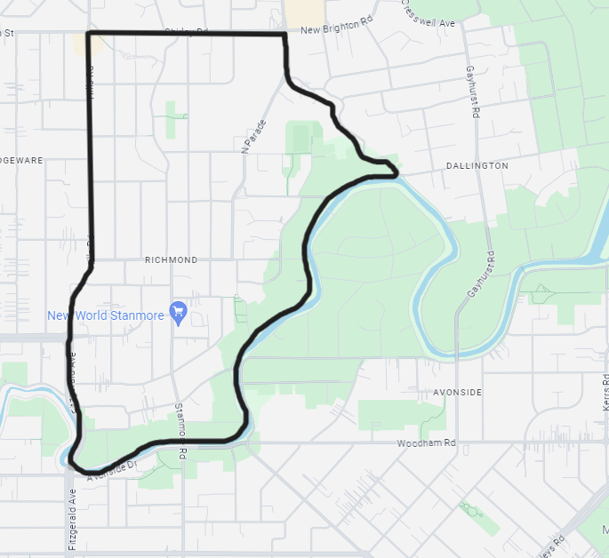

As part of the new Incorporated Societies Act regulations, We Are Richmond (Richmond Residents' and Business Association Incorporated) requires a Membership Register. Can you help us by signing up to be a member of We are Richmond? This will help us continue our work. Members do not need to attend monthly meetings, but are sent newsletters and are encouraged to get involved in any way possible. We have updated our Constitution and by becoming an Incorporated Society under the new act, we have access to funding to continue our projects, acting in the best interests of our community.

We Are Richmond serves and acts for the area of the city bounded by Fitzgerald Avenue, Whitmore Street, Hills Road, Shirley Road, North Parade, Banks Avenue and River Road.

To fill out the membership form, choose from these options:  
-Click here: <https://mailchi.mp/f6c2d24a254d/we-are-richmond-membership-form> 

-Scan the QR Code  
-Fill in the form below and email to [secretary@wearerichmond.co.nz](mailto:secretary@wearerichmond.co.nz)   
-Print and drop off at: 46A Vogel Street, Richmond, Christchurch 8013

Information you provide on this form is confidential to We are Richmond.

For further information about We Are Richmond [www.wearerichmond.co.nz](http://www.wearerichmond.co.nz) <https://www.facebook.com/wearerichmondchch/> or [secretary@wearerichmond.co.nz](mailto:secretary@wearerichmond.co.nz)

|  |
| --- |
| **NAME:** |
| **ADDRESS (including suburb and postcode):** |
| **PHONE:** |
| **EMAIL:** |

I am: (*please tick all that apply)*

* **Resident**
* **Business owner** (name and address of business .…………………………………………………...)
* **Investment property owner** (address of property ………………………………….…………..…...)
* **Part of a club or organisation that works in the Richmond Area**

(name of organisation ……………………..……………………………………………..………………...…..)