Minutes meeting 26 Aug ’25 held at Avebury House

**Present**

Murray James (chair), Liesbeth van Bruchem, Ewout van Bruchem, Rachel Crawford, Hayley Guglietta, Ross Skinner, David Duffy, Cheryl Doig, Kate Palmer, Craig Given.

**Apologies**

Jenna Kelly, Nick Hughes.

Murray opened the meeting at 7.02pm and we especially welcomed our new committee members with a name badge and a form to fill out: Kate Palmer and David Duffy!

We will do the same for Jenna at next month’s meeting.

The minutes from the previous meeting (24 June ‘25) were moved by Ewout and seconded by Rachel.

**Correspondence**

Hayley mentioned she has replied to Emily regarding Petrie Park and subsequently has written a letter to all residents, which Rachel distributed.

Delta has a community van that groups can use for people moving. Rachel informed Shirley Intermediate about this.

Murray mentioned that he has vehicles to transport stuff if people need that kind of transport.

We briefly talked about the starlings and the fact that the council keeps waterblasting the footpath, even though nesting season has finished. Rachel to follow up with Nick and maybe email council and the roading team regarding this.

There is an invoice that needs to be paid. Murray approved this for processing.

We received an email from Laura, who is a Richmond resident (and is most welcome to attend our meetings) regarding interviewing people in the Richmond Community Garden. Rachel will connect her with the correct people.

**Outgoing correspondence:**

Rachel spent quite a bit of time on the vaping issue and talked to residents who are concerned about the 4th vape shop opening up. She contacted Trevor Cattermole from CCC, Health New Zealand (Christina Lewis, smokefree Enforcement Officer), Cancer Society and Vape Free Kids NZ.

Hayley predicts that legislation regarding vape shops will come into place next year, so vape shops now need to off load all their product.

Rachel and Murray to write a submission to Duncan Webb and Reuben Davidson Also include the schools and ask them for a statement. Liaise with Philipstown and invite speaker to the RCAN meeting.

**Update from the Chair**

Murray indicated that the pool project at Shirley Intermediate will kick off again now that the weather is warming up. He attended a masterclass regarding pool compliance.

Murray will attend the deposition on the 12th of Sept regarding 10 Shirley Road. At this stage, we will not discuss anchoring the project, we will just get it started. The proposed building is a character build, 200 sq m, with wrap around verandah.

Similar to the one in Heathcote (see picture).

**Treasurer’s report**

Hayley tabled the treasurer’s report, since handover has not been done yet.

We need to register our annual report by the 30th of September with the Society’s Register.

**Capacity Builder**

Rachel told us that things are going well.

We received $17.000 from the Strengthening Communities Fund and you can read the submission, just ask Rachel.

Rachel has been doing lots of work for the meet the candidates evening and there’s another RCAN meeting coming up too.

The Spring Fair is coming up on the 18th of October. Get in touch with Rachel if you can help out on the day, with setting up, manning our WAR stall, and other bits and pieces.

Rachel also asked if anyone has a sound system and it was suggested to contact Shirley Intermediate regarding this. Ewout mentioned he has a speaker plus there’s also something in the Hub (contact Dave).

**Working groups**

**Roading**

Craig informed us that the works in Slater Street will commence on the 1st of September.

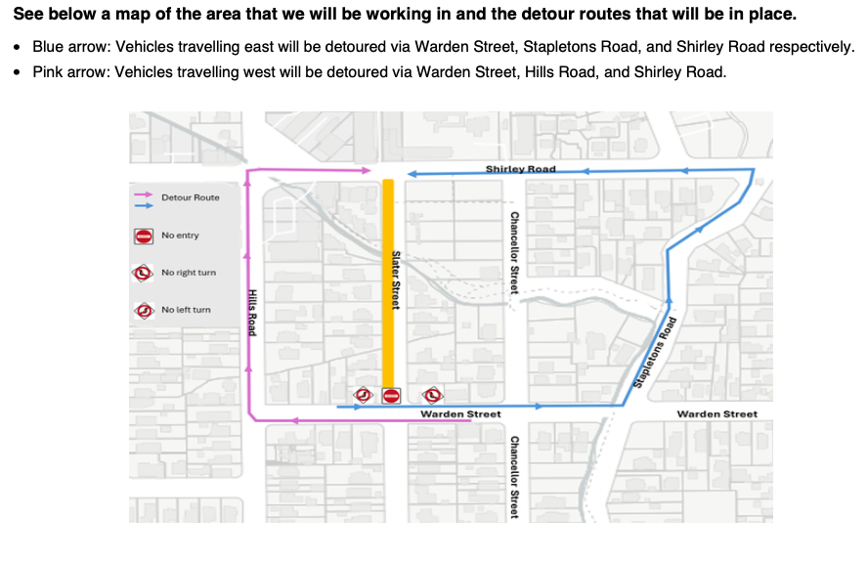Hayley explained that Slater Street has coal tar, which first needs to be researched, that’s why there was a delay.

Craig to keep liaising with Trevor Cattermole and Rachel to put the notices on the website.

Trevor mentioned in an email to Craig to use either of the following reporting tools for flooding issues:

**Stormwater and drainage**

Info on projects and the Council advice on **‘wet weather and flooding’**, and form to report a problem with stormwater or drainage: <https://www.ccc.govt.nz/services/water-and-drainage/stormwater-and-drainage>

‘**Report it’** portal also has a ‘water problem’ category to report under: <https://www.ccc.govt.nz/do-it-online#Report>

We talked about the cycleway and Hayley mentioned that there’s a completed plan. It is on the community board agenda.

**Communications**

Our website now has a different home page, not the We Are Richmond group, but pictures of all sorts of people in our community.

Check it out [www.wearerichmond.co.nz](http://www.wearerichmond.co.nz)

From this:

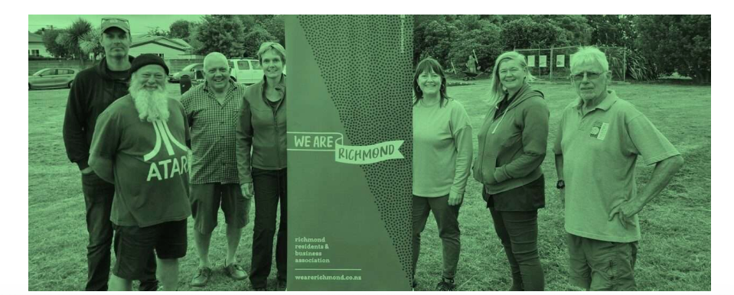

To this:



**Richmond Clean Ups**

David mentioned there’s an overgrown empty section in Alexandra Street where stuff gets dumped as well. We are wondering who to contact.

Liesbeth suggested snap send solve and say it’s a fire hazard, hopefully the council will contact the owners then.

The Medway parklet needs a tidy up again. Rachel and Liesbeth will try and engage the people that live there.

**Arts & Parks**

We’ll have a planting day at Petrie Park on Saturday the 30th of August from 2 till 4pm.

**Warden Street**

From Nick:

*Limited update from MOE other than noting that they have limited interest in establishing a Memorandum of Understanding (MoU) regarding the swale - I suspect too much effort and too little resources.*

*Broader status summary:*

*The School Board is outgoing but continuing to push to resolving broader site clarity to inform school requirements into the future. As such, this is likely to remain a talking point.*

*Hayley’s point of view seemed to err towards being that the planting has limited financial value and thus accepting the  “at risk” position for now. Regardless, WAR would need to continue to engage with the school to ensure protection of the swale assets should this area be used for access or staging of any future school development. The school seems to see the area as a growing asset to them and this would be inclined to protect it regardless, support from WAR / Hayley would likely be very welcome.*

Avon Otakaro, We Are Richmond and the school will co-host a working bee on Thursday the 18th of Sept from 5pm.

Rachel to put this on socials.

**Meet the candidates**

Ross updated us on the meet the candidates evening to be held on Wednesday the 3rd of September at the Richmond Club. It will be 2 hours (starting at 6.15pm). Nibbles (from 5.30pm) will be provided and the bar will be open.

Registrations are necessary and will be extended till the 2nd of September.

We need someone there with a laptop too so people can check if they are enrolled (in the correct ward).

We pre-approved spending money for this event.

**General business**

Liesbeth mentioned that Kainga Ora is selling Sorensons place. Check it out: <https://www.trademe.co.nz/a/property/commercial/sale/listing/5480426519?bof=EbjhZbr3>

Liesbeth was also wondering what the rules are regarding rubbish bins at bus stops. She will try and find out.

We have decided to do a summer with your neighbours in February. 2026

Liesbeth showed pictures of Eveleyn Couzins and how the residents of the social housing park their cars. It’s often very muddy there which makes it hard to walk. Liesbeth to contact council to see what can be done.

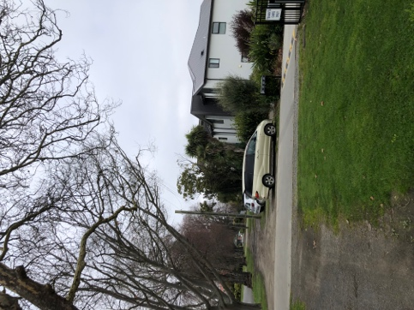 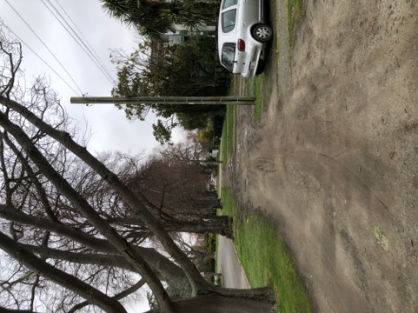

The RCN deadline for the October issue is on the 12th of September. Murray to write something.

We need to get the election signs out. Murray and Craig to ‘find’ them.

Meeting closed at 8.55pm

Next meeting will be on the 23rd of September at Avebury House, 7pm.

|  |  |  |
| --- | --- | --- |
| Date added: | Action Points | |
| 27 Aug | Follow up with Nick regarding footpath cleaning | Rachel |
| 27 Aug | Pay invoice Akiva | Murray/David |
| 27 Aug | Write submission regarding vape shops and send to Duncan Webb and Reuben Davidson | Rachel/Murray |
| 27 Aug | Register annual financial report with Society | Rachel |
| 27 Aug | Let Rachel know if you can help at Spring Fair on 18 October | Everyone |
| 27 Aug | Put working bee Warden Street - 18 Sept on socials | Rachel |
| 27 Aug | Find out what rules are regarding rubbish bins at bus stops | Liesbeth |
| 27 Aug | Pick a date in Feb for summer with your neighbours | Rachel/everyone |
| 27 Aug | Write article for RCN by 12 Sept | Murray |
| 27 Aug | Fix WAR sign at Richmond Village | Murray/Ewout |
| 28 May | Add dog Nui to the website | Hayley |
| 28 May | Design last history panel | Rachel |
| 28 May | Organise an event for the Medway parklet neighbouring residents | Rachel/Liesbeth |
| 28 May | Think of a competition to use vouchers | Rachel |
| 27 Nov ‘24 | Attach downpipe and chain at tattoo shop | Murray/Hayley |